AMERICAN INTERNATIONAL UNIVERSITY-BANGLADESH



Software Development Project Management

# Final Project

NAME: ARIAN RAHMAN

ID: 19-39515-1

Section: A

Project Title: Animal Welfare Software Application.

Introduction: In this application we will focus on giving support to the animals in need. Our system will help people to know where they should go or ask for help or any kind of emergency situation. Also we will try to make an easy to use of communication service between animal lovers and veterinarians. In our System we have a part for Purchase animal foods and toys. Animal adoption is also available in our system. People can write blog or can Share Videos so that others can be motivated and get some knowledge. Our system will help to make sympathy on an animal and also make proper caring of an animal to create our eco system better.

Objectives: The main purpose of the system is to support the animal need. The general users of the system can request for adaption of animal. If the animals face any illness System will allow general users to consult with veterinarian. The shop owner also can sell products for the animals. So the main goal of the system is welfare of the animals.

Justification: By using this system general users, veterinarians, shop owners all will be benefited. They can easily communicate with each other. As a result, our animal welfare system will run smoothly. Animal welfare process will be easier. Veterinarian can easily provide treatment animals. General users easily buy products. Shop owners can easily sell the products. All of the users can be benefited. As a result, animal welfare process will be trouble free. So our system is perfect for the welfare of animals.

Systems Overview:

Use case diagram

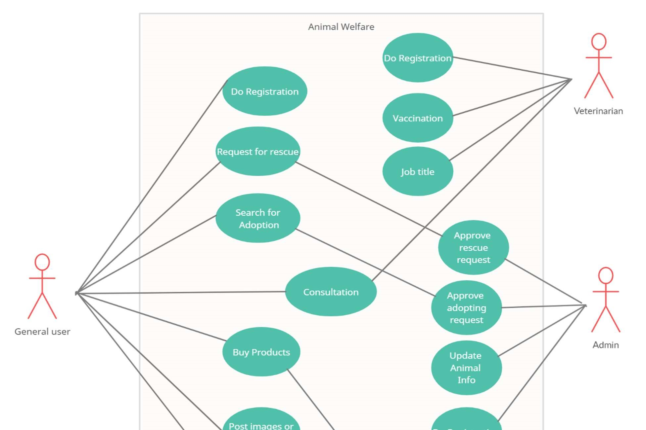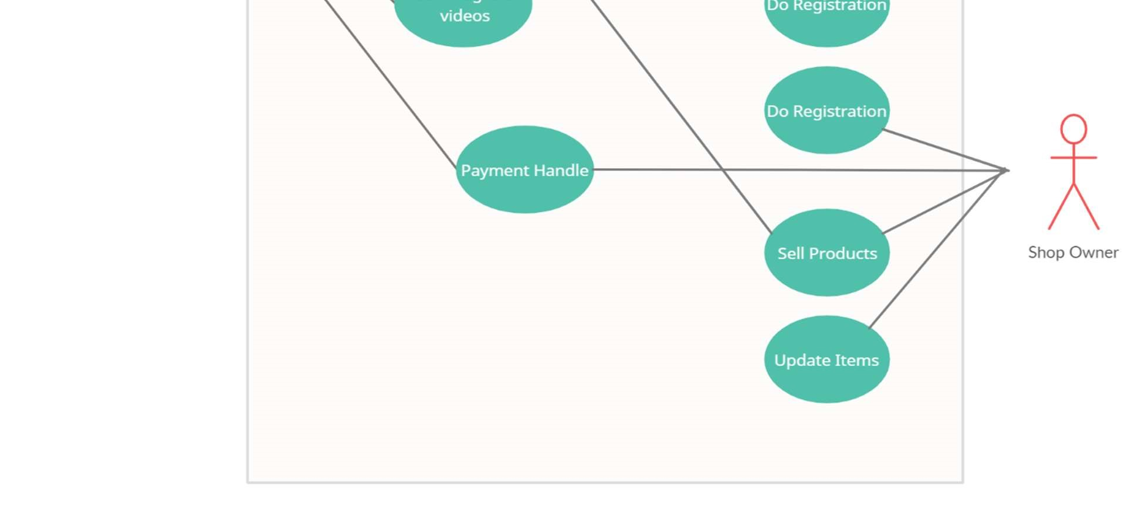

Stakeholders analysis: There are four types of stakeholders of our system. They are,

1. Primary Stakeholders: General User, Customer, veterinarian, shop owner
2. Secondary Stakeholders: Admin
3. Internal Stakeholders: Developer, Program Manager

Feasibility study: Feasibility is defined as the practical extent to which a project can be performed successfully. To evaluate feasibility, a feasibility study is performed, which determines whether the solution considered to accomplish the requirements is practical and workable in the software. Information such as resource availability, cost estimation for software development, benefits of the software to the organization after it is developed and cost to be incurred on its maintenance are considered during the feasibility study. The objective of the feasibility study is to establish the reasons for developing the software that is acceptable to users, adaptable to change and conformable to established standards.

A: Requirements Analysis - 25 days

B: Designing /Modeling - 30 days

C: Coding part - 60 days

D: Testing part - 30 days

E: Implementation - 25 days

F:

Maintenance - 5 days

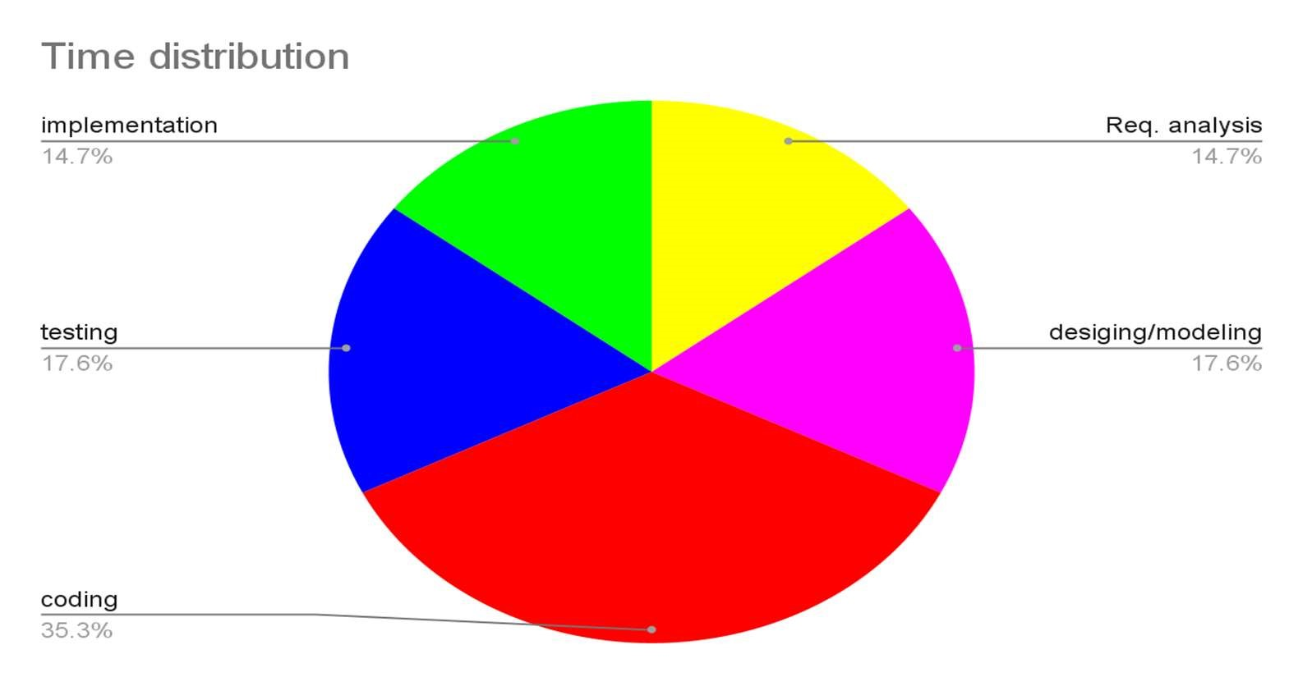

Time distribution of complete project to check either the project is feasible or not.

System components: crucial system component chart is given below: -

|  |  |  |  |  |
| --- | --- | --- | --- | --- |
| Animal welfare software application system | | | |  |
|  | | | |  |
| Initial study | Feasibility study | Planning and analysis | Development | System testing |

|  |  |  |  |  |
| --- | --- | --- | --- | --- |
| Determine project scope | Technical feasibility | Establish project team | Define UI/UX | Develop system testing environment |
| Secure project sponsorship | Operational feasibility | Generate project plan | Write user acceptance | Define system testing method |
| Justification method | Strategic feasibility | Budget and functionality | Generate requirement matrix | Allocate time and resource |
| Define resources | Operational feasibility | Define development environment | Verify user acceptance | Define defects and drawbacks |
| Emerged solution | Feasibility study complete | Define risk analysis | Project  management plan | Refer to the relevant development section |
| — | — | Define impact analysis | Development complete |  |
| — | — | Develop delivery timeline | — | — |
| — | — | Planning and analysis complete | — | — |

Process Model: In this project COCOMO process model is applied. Which is a parametric productivity model. This model is based on source lines of code characteristics.

|  |  |  |  |  |
| --- | --- | --- | --- | --- |
| Software Project  Type | Coefficient | P |  | T |
| Organic | 2.4 |  | 1.05 | 0.38 |
| Semi Detached | 3 |  | 1.12 | 0.35 |
| Embedded | 3.6 |  | 1.20 | 0.32 |

Effort estimation: Basically this is an organic project and we are considering the COCOMO method for the project estimation. As this project is going to be implemented by a small group of human resources and a very familiar in-house software development environment.

|  |  |  |  |
| --- | --- | --- | --- |
| Software project type | Coefficient <Effort factor> | P | T |
| Organic | 2.40 | 1.05 | 0.38 |

PM: Person-month needed for project SLOC: Source lines of code

P: Project complexity (1.04 – 1.24)

DM: Duration time in months for project

T: SLOC dependent coefficient (0.32 – 0.38)

As This is an organic project it is expected to write 7,000 lines of code where the coefficient of effort factor is 2.4, Project Complexity (P) is 1.05, and SLOC-dependent coefficient (T) is 0.38. So, we need the estimation of total effort, total development time and required number of people needed in this project.

* Effort = PM = Coefficient<Effort Factor>*(SLOC/1000)^P

= 2.4*(7000/1000)^1.05

= 2.4*(7)^1.05

=18.52 person months

* Development time = DM = 2.50*(PM)^T

= 2.50*(18.52)^0.38

= 7.58 ≈ 8 Months

* Required number of people = ST = PM/DM

= (18.52)/ (7.58)

= 2.44

≈ 3 peoples

Activity Diagram: Activity network diagram is used for scheduling of the project. Here we by doing this diagram we can analyze our animal welfare systems activity planning and execution. By this diagram we can easily maintain our schedule. As a result, we perform our system more properly.

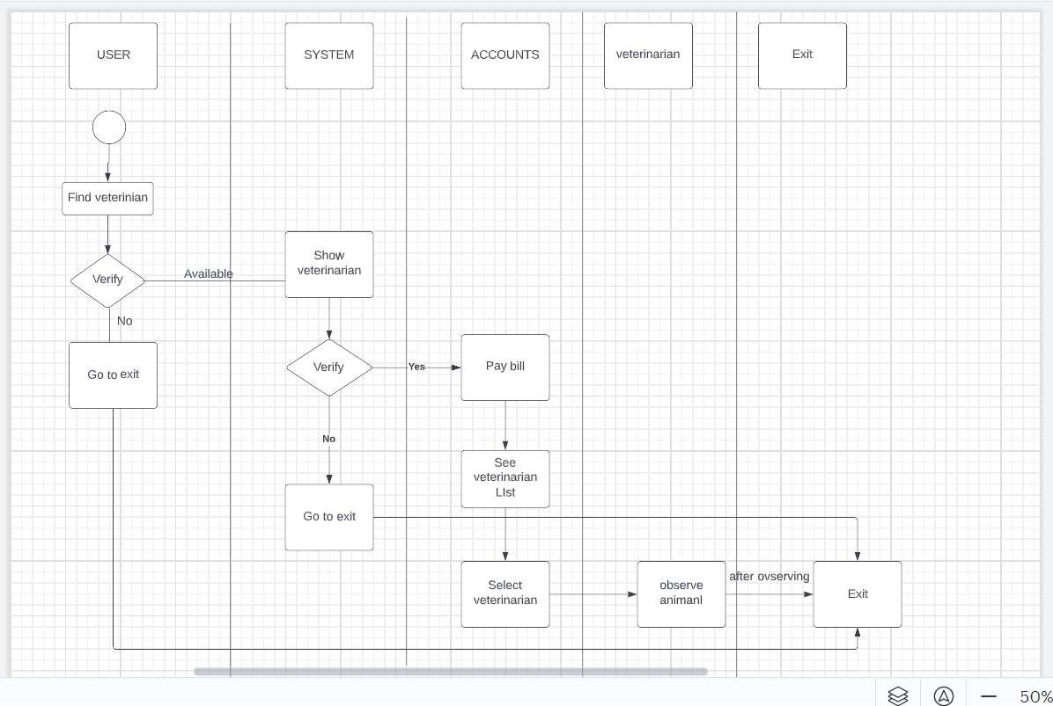

|  |  |  |
| --- | --- | --- |
| Activity | Duration (Days) | Precedence |
| A | 25 | None |
| B | 30 | A |
| C | 60 | A,B |
| D | 30 | C |
| E | 25 | D,C |
| F | 6 | D, E |



A

B

D

E

C

F

Fig: Activity Network Diagram

Activity Labeling Convention:

|  |  |  |
| --- | --- | --- |
| Earliest Start (ES) | Duration | Earliest Finish (EF) |
|  | Activity Level | |
| Latest Start (LS) | Float | Latest Finish (LF) |

Activity Network Diagram:

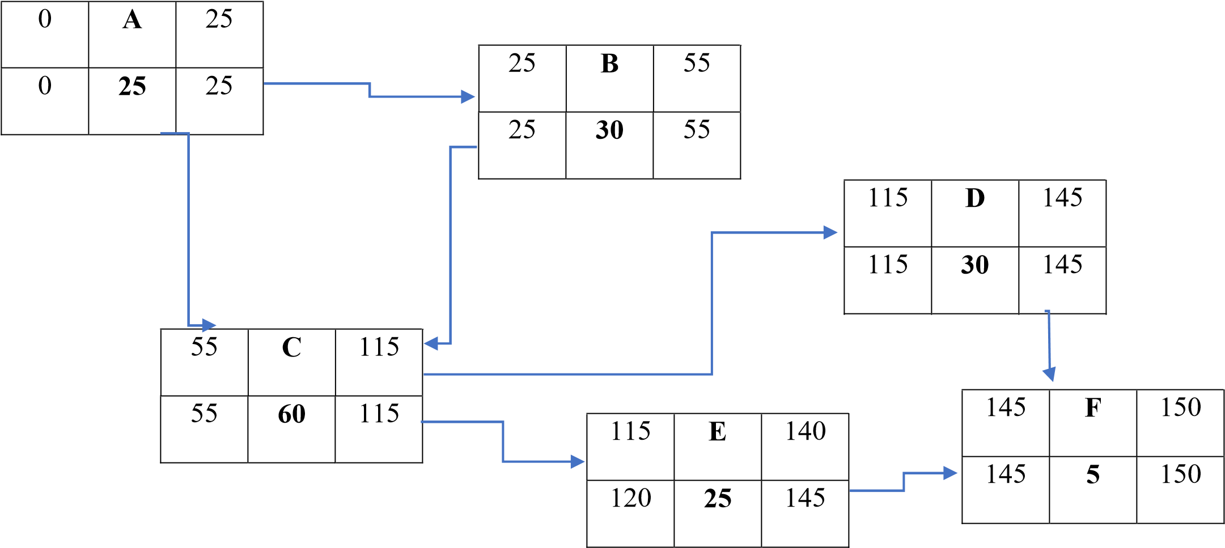

All Possible Paths: Path-1:



A



B



C



E



F

Path-2:





3:

Path-



A



C



E



F



A



C



D



F



Path-4:



A



B



C



D



F

Here, Path-4 is the critical path.

Risk Analysis:

Risk Table:

|  |  |  |  |  |
| --- | --- | --- | --- | --- |
| Risk | Probability | Likelihood | Impact | Risk Exposure |
| 1. Staff inexperienced | 30% | 3 | 7 | 21 |
| 2. Lack of training and tools | 40% | 4 | 5 | 20 |
| 3. Less reuse than planned | 45% | 5 | 5 | 25 |
| 4. Customers payments can be lost | 20% | 2 | 4 | 8 |
| 5. Animal food delivery can be hampered | 40% | 4 | 8 | 32 |
| 6. Staff turnover might be high | 50% | 5 | 3 | 15 |
| 7. Technology cannot fill the expectations | 30% | 3 | 2 | 6 |
| 8. Developing wrong functions | 30% | 3 | 2 | 6 |
| 9. Larger number of user than planned | 60% | 6 | 7 | 42 |
| 10. Unrealistic time | 40% | 4 | 6 | 24 |
| 11. Incorrect budget estimation | 30% | 3 | 4 | 12 |
| 12. Poor code quality and technical risk | 25% | 3 | 8 | 24 |
| 13. Animal Doctors availability | 40% | 4 | 7 | 28 |
| 14. Developing wrong user interface | 50% | 5 | 8 | 40 |
| 15. Lack of architectural design | 40% | 4 | 4 | 16 |
| 16. User documentation missing | 45% | 5 | 6 | 30 |
| 17. Real-time performance Shortfalls | 50% | 5 | 7 | 35 |
| 18. Introduction to new technology | 20% | 2 | 5 | 10 |

Budget for the project:

Requirement analysis:

Required time = 25 working days = 25*8 working hours = 200 working hours

Requirement analysis persons per hour salary = 300 Taka

Total requirement analysis salary = 300 * 200 = 60,000 Taka

Developer salary of 8 months:

Required time = 8 months = 8*22 working days = 176*8 working hours = 1408 working hours

Per developer salary per working hour = 500 Taka Total developer salary = 500*1408 = 7,04,000 Taka

Project manager’s salary for 8 months:

Per month salary = 30,000 Taka

Total salary = 30,000 * 8 = 2,40,000 Taka

Accountant’s salary for 8 months:

Per month salary = 8,000 Taka

Total salary = 8,000 * 8 = 64,000 Taka

Maintenance (Till 3 months after delivery):

Cost per hour = 1000 Taka

Total estimated time needed for maintenance = 60 hours

Total estimated maintenance cost = 1000 * 60 = 60,000 Taka

Transportation cost: 12,000 Taka (Approximate)

Special training & Hardware expenses: 1,20,000 Taka (Approximate)

Rent expenses:

Room per month = 20,000 Taka (Approximate)

Total in 8 months = 20,000*8 = 1,60,000 Taka (Approximate)

Total utilities bill in 8 months:

Utility bill per month = 3500 Taka (Approximate)

Total in 8 months = = 3500*8 = 28,000 Taka (Approximate)

Total estimated expense: (60,000 + 7,04,000 + 2,40,000 + 64,000 + 60,000 + 12,000 + 1,20,000 + 1,60,000 + 28,000) = 14,48,000 Taka

Profit:

25% of total estimated expense = 14,48,000 * 25% = 3,62,000 Taka

Total budget for the project: 14,48,000 + 3,62,000 = 18,10,000 Taka

Conclusion: The paper ensures the goal of the software to achieve the welfare of animals. It's an easy to use software. It ensures the safety, wellbeing of animals. And a relief to the pet owners. Pet owners will be able to receive quick services and solutions for their pets. This software offers the knowledge about animals, free suggestions of people, can give directions m what to do or not do, where to take help, nearby veterinary, purchasing animal goods, direct contact with vets, adoption of animals, locate animal day care organization, news about animals like if stray animals are in trouble interested people can help etc. Therefore, it's a full package of animal welfare.